Telusko: Advance Java 05

161 Profiles in spring boot and its need, project of profiles using RealTime DI

Profiles in SpringBoot
======================
=> Both Spring and SpringBoot supports profiles
=> In all approaches of Spring app development we can use profiles
a. xml driven
b. annotation driven
c. 100% code configuration
d. springboot
=>Environment means the setup which is required for executing the app/project
it contains compiled code + server + dbs/w + jar files + properties/yml etc....
=> From the development to production of the project we come across multiple
environment where code needs to be executed
for different purpose.This environment is called "Profile".
a. Dev environment/Dev profile
b. test environment/Test profile
c. uat environment/uat profile
d. prod environment/prod profile
etc....
In our SpringApp/project
a. To make Sterotype annotation based spring class participating only on
certain profiles activation we use
"@Profile" on top of Spring bean class like @Profile("dev") or
@Profile({"dev","test"})
note: if no @Profile is specified the spring bean is available for all the
profiles.
@Repository("mySQLEmployeeDAO")
@Profile({"dev","test"})
public class MySqlEmployeeDaoImpl implements IEmployeeDAO{
}
@Repository("oracleEmployeeDAO")
@Profile({"uat","prod"})
public class OracleEmployeeDaoImpl implements IEmployeeDAO{
}
b. To make @Bean method of @Configuration class returned a java class object
which represents a sprint bean working on certain profiles
then @Profile annotation should be used on top of @Bean method
@Configuration
public class PersistenceConfig{
@Bean("dsDBCP2")
@Profile("dev")
public DataSource createUsingDBCP2(){
}
@Bean("dsOraUCP")
@Profile("dev")
public DataSource createUsingOracleUCP(){
}}
=> To keep application.properties/yml file into specific one profile, we create
seperate properties file for that profile as shown below
syntax:: application-<profile>.properties/yml
application.properties
application-dev.properties/yml
application-uat.properties/yml
application-pro.properties/yml
application-dev.properties/yml
How to activate the specific profile
a. In application.properites/yml
spring.profiles.active = dev
b. using -Dspring.profiles.active = dev(system property with value)
Note: if any give profile related properties file is not available then it will use
application.properties file as fallbackproperties file.
=> Getting employee record on the basis of Designation... use VO,BO,DTO
EMPDTO
=====
empNo
empName
job
sal
deptNo
MgrNo
controller => List<EmployeeVO>showEmpsByDesg(String[] desg)
service => List<EmployeeDTO>fetchEmpsByDesg(String[] desg)
dao => List<EmployeeBO> getEmpsByDesg(String cond)
sequence:: client<======VO======controller<=====DTO=====> service<=====BO=======
DAO
Tommo
=====
yml usage and benefits in profiles
Commandline Runners
Till monday
===========
SpringJDBC,SpringORM,SpringDataJPA
SpringBootMongoDB,SpringMVC(introduction)
recorded videos
===============
Maven,Junit,lombok,log4j,SpringBootlogging(videos)
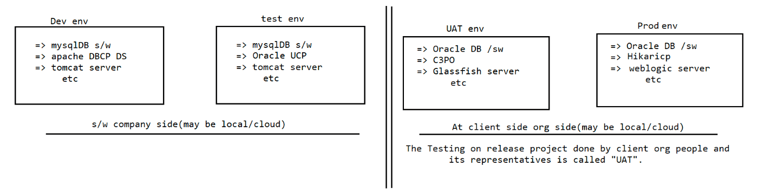

162 maven multimodule,project for maven multi module, usage of log4j, Important object used in logging, one example using jdbc to demonstrate the usage of Log4j

Maven[GAV]
=====
Maven Repositories
a.local(.m2) 2.Central(http://maven....) 3. RemoteRepository(3rd party
team)
Maven archetype[quickstart,webapp]
Maven LifeCycle
a. clean b.default 3.site
Maven features
a. properites b. exclusions
Maven inheritance[<parent><GAV></parent>]
Maven MultiModule
While working with archetype webapp,we need to inform maven about
a. servlet-api
b. jstl-api
c. hibernate-api in pom.xml file
since it is webapplication, to use jstl inside jsp we need to inform the namespace
inside web.xml file as shown below.
web.xml
=======
<web-app
xmlns:xsi="http://www.w3.org/2001/XMLSchema-instance"
xmlns="http://java.sun.com/xml/ns/javaee"
xmlns:web="http://java.sun.com/xml/ns/javaee/web-app_2_5.xsd"
xsi:schemaLocation="http://java.sun.com/xml/ns/javaee
http://java.sun.com/xml/ns/javaee/web-app_2_5.xsd"
id="Your_WebApp_ID"
version="2.5">
</web-app>
Maven Multi-Module Project
==========================
Whatever project we created so far are single module projects. The concept of
Multi-Module Project is very simple.
When various modules are part of a project and closely related to each other, then
the project should be structured as a
multi module project.
In a multi module project, Maven ensures that all sub modules are built in proper
order before the main module build.
According to agile methodology, we take muitiple layers as multiple modules in a
project.
All DAO classes together in one module, all service classes together in one module
and all web components together in one
module. To develop such projects in maven, we can take maven multi-module project.
MavenMultiModule(pom)===>in.ineuron
|=> WishServiceModule(jar)
com.pwskills.service
|=> WishMessageService.java
|=> WishWebModule(war)
|
src/main/java
|=> com.lco.controller
|=>webapp
|=> WEB-INF|=> index.jsp(landing page)
WishMessageService.java
=======================
package com.pwskills.service;
public class WishMessageService {
public String wishMsg(String user) {
return "Good Morning :: " + user;
}
}
index.jsp
=========
<%@ page import="com.pwskills.service.WishMessageService"%>
<h1 style='color:red; text-align: service'>
<%= new WishMessageService().wishMsg("AlakPandey")%>
</h1>
Log4J and SL4J
==============
What is Logging?
The process of keeping track of application's flow of execution is called
"Logging".
using logging generated log messages we can find the state of the application
execution in any given date and time
logging keeps track of components and code that are involved in application
execution.
Auditing
=======
of application.
application execution]
logging keeps track of various components and code that are involved in execution
[getting classname,methodnames,blocks,modules that are involved in
Auditing keeps track of various activities done by the user while operating the
application.
signedout]
[getting the activities like usersignedin,opened inbox, repliedmail,.....
Note: Auditing is one of the use case of "logging".
The special log messages of logging that keeps track of user activities w.r.t
application execution is called "Auditing".
Use case of Logging
===================
=> While performing unit testing,if the test results in negative we need to debug
the code to know the reason, in that case log
messages are useful for developers
=> While fixing the bugs given by tester,the developers needs to know the state of
the application execution that needs the
support of log messages.
=> After releasing the project,we get production bugs from clients org given by end
users through onsiteteam, the offshore team
uses the log messages to know the state of the execution when bug was rised
through log messages.Note:
onsite =>go to client org location to recieve,install,maintain the project
offsite =>stays in the software company to release the project and fix the
production bugs given by client org.
offsite team is a supporting team to onsite team.
While maintaining the project there will be production environment,if the project
is down all of a sudden then the maintainence
team sends the exception related to special log file to know the reason and fix the
problems.
while taking the backup of DBS/w and bringing the DB s/w back to normal software
after crash, we take the support of logs.
While performing transaction support, we need the support of log messages.
Every project contains the following 4 environments
a. Dev environment.
b. Testing environment.
c. UAT environment.
d. Production environment.
UAT,Production => belongs to Client organisation
Note: The code related to logging will be added to project during devleopment only,
but it will used in different phases of the project.
We can do logging in java applications using
a. System.out.println()
b. System.err.println()
but the above 2 methods are having limitations
a. We cannot write log messages only to the console monitor while will be lost
after some amount of time.
b. We cannot categorize log messages
c. We cannot format log messages
d. We cannot write log messages to different destinations like
file,dbs/w,mailserver etc....
e. We cannot see old log messages after few days/hours(particular date and time log
messages)
f. We cannot filter log messages while retreiving
g. Writing messages to console monitor using System.out.pritln() is a single
threaded process,so this is not suitable in case
of web environment(webapps).
To overcome this problems we need to go for
a. JavaAssertions (from JDK SunMS)
b. Javalogging api given in java.util package(from JDK SunMS)
c. commons logging(apache)
d. jboss logging(redhat)
e. log4j(apache => best in market)
f. logback (adobe)
SL4J
-> It stands for Standard Simple logging facade for Java
-> It provides abstraction on mulitple logging api/tools/framework and provides
unified api for logging by internally using
our choice logging api.
SL4J(framework)[SUNMS]log4j
logback
commons-logging
Log4j
=====
type : logging tool for java
version : 1.X(stable) 2.X(not stable)
vendor : apache
open source
jar file representing api: log4j-<ver>.jar(download from maven repository)
To download log4j s/w::
https://www.apache.org/dyn/closer.cgi/logging/log4j/1.2.17/log4j-1.2.17.zip
Log4j Advantages
================
1. Allows to categorize the log messages and we can add priorities for log
messages.
DEBUG<INFO<WARN<ERROR<FATAL
Use DEBUG level for normal confirmation code flow statements
eg: main() method start,main() end ,start of b.method and end of b.method
etc...
Use INFO level for important confirmation of code flow statements
eg: connection established with DB s/w, login successfull, OTP
generated,.....
Use WARN level to write log messages for code that should not used/executed but
some home used and executed.
eg: especially useful when we used deprecated api's/poor api's on temporary
basis.
like
Use ERROR level to write log messages from know exceptions related to catch blocks
(SQLException e),catch(IllegalArgumentException e)
Use FATAL level to write log messages from unknow exceptions related catch blocks
like (Exception e),catch(Throwable t) etc.
In testing environment what is the difference b/w bug and issue?
bug => code exists, but the expected functionality is not coming(wrong logic)
eg: click on home hyperlink,redirecting to aboutus page.
issue=> feature/functionality is missing.
2. Allows us to write/record log messages to different destinations like
console,files,dbs/w,mailserver etc.
3. Allows us to format log messages using different layouts like (HTML layout,
XMLLayout...)
4. Allows to retreive log messages using filters
ALL<DEBUG<INFO<WARN<ERROR<FATAL<OFF
Note: In realtime for every app 2 log-files will be maintained
a. Common log files(records all logs messages end to end)
b. Exception log files(records only ERROR and FATAL level log
messages.. useful when system/project is down)
5. Can change the inputs of the app related to log4j either using properties file
or xml files.6. Log4j can write log messages to files/console/other destination as parallel
process.
7. It is industry standard.
Three important object of Log4j Programming
===========================================
a. Logger object
b. Appender object
c. Layout object
Logger Object
=============
=> enables logging on the given java class.
=> Logger logger = Logger.getLogger(current java class related to
java.lang.Class object);
eg: Logger logger = Logger.getLogger(BankAppProject.class);
=> use the following method based on the priority level to generate the log
message
logger.debug("");
logger.info("");
logger.warn("");
logger.error("");
logger.fatal("");
=> Allows to specify logger level to retrieve log messages
logger.setLevel(Level.DEBUG)[if no logger level is given then the
defualt logger level is DEBUG]
=> Both Appender object and Layout object will be added to logger object
directly or indirectly.
=> Instructions/Inputs to logger object can be hardcoded or given by using
properties file/xml file.
Appender Object
===============
=> specifies the destination where to write/record the log messages.
eg:
FileAppender,RollingFileAppender,DailyRollingFileAppender,JDBCAppender,
IMAPAppender,ConsoleAppender
=> All Appender classes implements from org.log4j.Appender(I).
Layout Object
=============
=> Given to format the log messgaes before givinig to appender for
recording/writing the destination file
eg: SimpleLayout,HtmlLayout,XmlLayout,PatternLayout......
=> All Layout classes extends from org.log4j.Layout(c)
Log4j Architecture
==================
refer diagram
step1: Create a maven standalone project
step2: Add the following dependancy to pom.xml file
pom.xml=======
<!-- https://mvnrepository.com/artifact/com.mysql/mysql-connector-j -->
<dependency>
<groupId>com.mysql</groupId>
<artifactId>mysql-connector-j</artifactId>
<version>8.0.32</version>
</dependency>
<!-- https://mvnrepository.com/artifact/log4j/log4j -->
<dependency>
<groupId>log4j</groupId>
<artifactId>log4j</artifactId>
<version>1.2.17</version>
</dependency>
<!-- pluging to make maven run a java code -->
<plugin>
<groupId>org.codehaus.mojo</groupId>
<artifactId>exec-maven-plugin</artifactId>
<version>3.1.0</version>
<executions>
<execution>
<id>JDBCAPP</id>
<phase>package</phase>
<goals>
<goal>java</goal>
</goals>
</execution>
</executions>
<configuration>
<mainClass>in.ineuron.JdbcApp</mainClass>
</configuration>
</plugin>
package in.ineuron;
import java.sql.Connection;
import java.sql.DriverManager;
import java.sql.ResultSet;
import java.sql.SQLException;
import java.sql.Statement;
//classes related to log4j
import org.apache.log4j.ConsoleAppender;
import org.apache.log4j.Level;
import org.apache.log4j.Logger;
import org.apache.log4j.SimpleLayout;
public class JdbcApp {
private static Logger logger = Logger.getLogger(JdbcApp.class);
static {
SimpleLayout layout = new SimpleLayout();
ConsoleAppender appender = new ConsoleAppender(layout);
logger.addAppender(appender);
logger.setLevel(Level.ERROR);
}public static void main(String[] args) {
logger.debug("start of main method...");
Connection connection = null;
Statement statement = null;
ResultSet resultSet = null;
try {
Class.forName("com.mysql.cj.jdbc.Driver");
logger.debug("Driver class loaded succesfully...");
String url = "jdbc:mysql:///octbatch";
String user = "root";
String password = "root";
connection = DriverManager.getConnection(url, user, password);
logger.info("connection established");
statement = connection.createStatement();
logger.debug("statement object created...");
String sqlSelectQuery = "select sid,sname,sage,saddress from
student";
resultSet = statement.executeQuery(sqlSelectQuery);
logger.info("Query is executed and ResultSet object is created");
while (resultSet.next()) {
System.out.println(resultSet.getInt("sid") + "\t" +
resultSet.getString("sname") + "\t"
+ resultSet.getInt("sage") + "\t" +
resultSet.getString("saddress"));
}
} catch (ClassNotFoundException c) {
logger.error("Failed to load the driver");
} catch (SQLException se) {
logger.error("Some db problem " + se.getMessage() + "----> " +
se.getErrorCode());
} catch (Exception e) {
logger.fatal("Some unknown exception occured...");
} finally {
try {
if (resultSet != null) {
resultSet.close();
}
} catch (SQLException e) {
logger.error("Problem in closing resultSet");
}
try {
if (statement != null) {
statement.close();
}
} catch (SQLException e) {
logger.error("Problem in closing statement");
}
try {
if (connection != null) {
connection.close();
}
} catch (SQLException e) {
logger.error("Problem in closing connection");}
}
logger.debug("end of main method");
}
}
right click on maven=> run as maven build -> in goals section type as exec:java
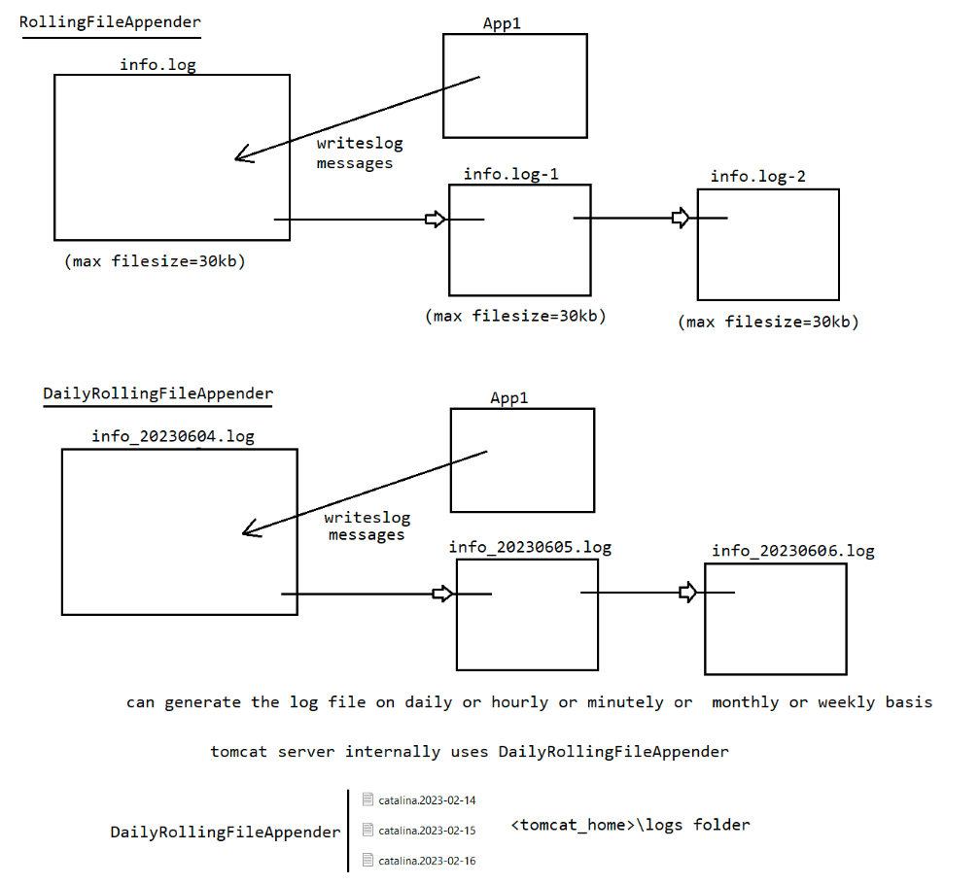
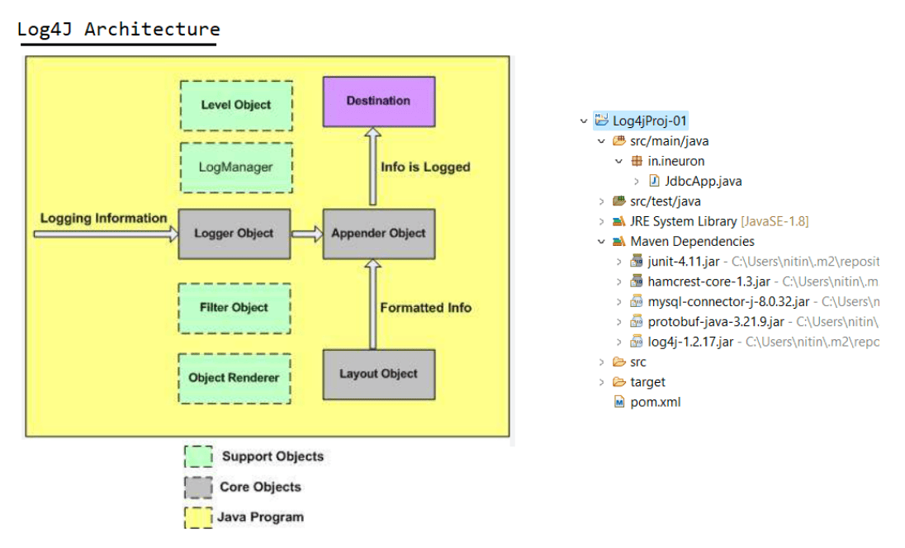

163 spring jdbc using xml and SpringBoot approach,usage of RowMapper interface

SpringJDBC(SpringDAO)
=====================
=> It provides abstraction on plain jdbc technology and simplifies jdbc style
persistence logic development
by avoiding boiler plate code.
PlainJDBC
========
a. load the driver
b. establish the connection
c. create JDBC Statement object
d. send and exeucte query
e. gather results and process results
f. perform exception handling
g. perform transaction management
h. close jdbc objects
In the above steps d,e specifies application logic whereas remaining steps
corresponds to boiler plate code.
=> In case of SpringJDBC application the boiler plate is take care by SpringJDBC
API's.
a. Inject JdbcTemplate class having DataSource object.
[Steps :: a,b,c,f,g,h] boiler plate code will
be taken care by JdbcTemplate
b. Send and execute the query
c. Gather results and process results
[Application specific logic should be taken
care by programmers]
SpringJDBC Advantages
=====================
1. Supports both positional(?) and named argument(:=name)
2. we can get "select query" results in different format directly with the support
of
query()queryxXXX(),queryForList(),queryForMap(),queryForObject()....
3. customization of Result is bit easy because it uses "CallBackInterface".
4. Provides abstration on plain jdbc and avoids boiler plate code(common logic will
be generated automatically)
5. Give detailed exception class hierarchy which is called
"DataAccessException"class hierarchy
a. Exceptions are made as unchecked excpetion.
b. Excpetion handling is optional.
c. Supports exception propogation by default.
d. These are exceptions which are common for SpringORM,SpringDataJPA
modules also.
e. Spring JDBC internally uses Exception rethrowing concept to convert
all the checked exceptions to uncheckedExceptions.
6. Simplifies the call of StoredProcedure
7. Gives the great support to work with Generics and var-args
8. It can generate insert sql query dynamically based on the given
dbtablename,colname,and colvalues.
Different approaches of developing persistence logic===================================================
a. using JdbcTemplate
b. using NamedParameterJdbcTemplate
c. Using SimpleJdbcInsert,SimpleJdbcCall
d. MappingSQLOperation as subclass
JdbcTemplate with CallBackInterfaces
====================================
1.RowMapper<T>
2.ResultSetExtractor
3.RowCallBackHandler
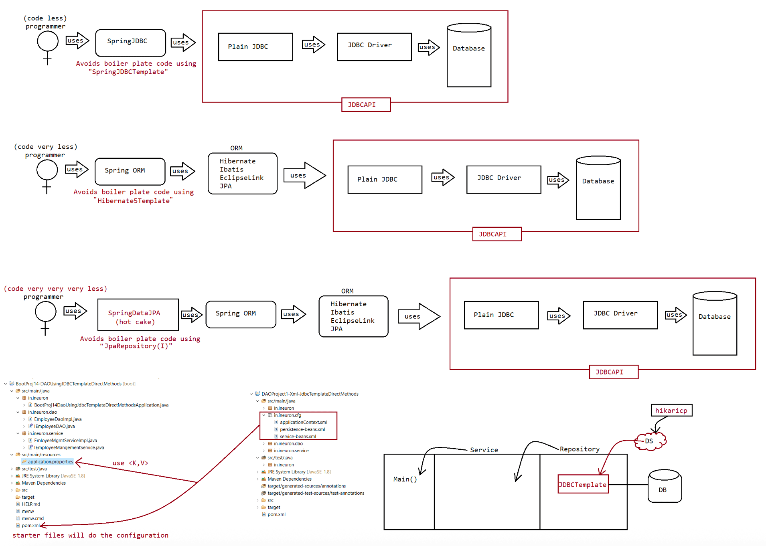

165 SpringBootJDBC using NamedParameterJDBCTemplate,calling StoredProcedure and setting values using Map and other types.

Mon,Wednesday,Thursday => 6.30 to 9.00AM IST
SpringDataJpa,SpringBootLogging(SL4J),SpringBootErrorExceptionHandling(MVC)
SpringJDBC
|=> JdbcTemplate(C)
|=> for Nonselect/DMl sql queries
a. public int update(String query)
|=> for select query
a. public xxxx queryXXXXX(,,)
Note:
While performing retrieval operation, to convert the data from ResultSet
Object to Buisness Object,SpringJDBC
environment has provided a predefined interface in the form of "RowMapper".
public interface RowMapper<T>{
public Object mapRow(ResultSet rs,int rowCount);
}
default implementation class is :: BeanPropertyRowMapper.
This class will take care of copying the record from ResultSet to BO.
Expectation : colnames in dbTable and BO properties/fieldname should be
same.
Working with ResultsetExtractor<T> callback interface
=====================================================
=> if select query is executed which gives multiple records to process then we
need to go for ResultSetExtractor/RowCallBackHandler
=> The best use case is getting List<BO> from RS after executing Select SQL query
that gives multiple records.
public interface ResultSetExtractor<T> {
T extractData(ResultSet rs) throws SQLException, DataAccessException;
}
default implementation class is :: RowMapperResultSetExtractor.
This class will take care of keeping the record into List<BO>.
default implementation class is :: BeanPropertyRowMapper.
This class will take care of copying the record from ResultSet to BO.
Expectation : colnames in dbTable and BO properties/fieldname should be
same.
eg::: return jdbcTemplate.query(GET_STUDENT_BY_CITY,
new RowMapperResultSetExtractor<StudentBO>(new
BeanPropertyRowMapper<StudentBO>(StudentBO.class)),
city1, city2, city3);
Working with RowCallBackHandler<T> callback interface
=====================================================
@FunctionalInterface
public interface RowCallbackHandler {
void processRow(ResultSet rs) throws SQLException;
}
=> A RowCallbackHandler object is typically stateful, it keeps the result state
with in the object, to be availble for
later inspection.ResultSetExtractor(I)
=> it is stateless in nature
=> extractData(,) call back method,but executes only once.
=> involves only one ResultSet
=> Good in performance
=> Support of Generics
=> Readymade implementation class is available.
RowCallBackHandler(I)
=> it is stateful in nature
=> processRow(,) call back method,executes for multiple times.
=> Involves mulitple ResultSet(n+1) in the entire process
=> Bad in performance
=> No support of generics
=> No ready made implementation class.
NamedParameterJdbcTemplate
==========================
It is similar to JdbcTemplate only,but it works with named parameter.
NamedParameterJdbcTemplate supports both positional(?) and named parameter(:)
eg: select empno,ename,job,sal from employee where empno>=? and empno<=?
(positional parameter)
select empno,ename,job,sal from employee where empno>=:no1 and empno<=:no2
(named parameter)
Setting the value to NamedParameterJdbcTemplate
===============================================
a. using Map<String,Object> obj
b. Using SQlParameterSource(I) implementation
a. MapSqlParameterSource(c)
=> it uses addValue(,,) takes param name and value as the
arguments.
b. BeanPropertySqlParameterSource(c)
=> it allows to set javabean object values as the
namedparameter values
condition: propertyname and parameter name should
match.
SimpleJdbcCall
==============
=> It is a multithreaded,reusable object representing a call to stored procedure.
=> It provides meta data for processing to simplify the code needed to access
basic storedprocedures.
=> All we need to do is provide the name of storedprocedure and map containing the
parameters when you execute the call.
=> The names of supplied parameters will be matched with IN and OUT parameters
declared when the stored procedure is created.
Storedprocedure
===============
CREATE DEFINER=`root`@`localhost` PROCEDURE `P_GET_PRODUCT_BY_NAME`(IN name1
VARCHAR(20), IN name2 VARCHAR(20))
BEGIN
SELECT pid,pname,price,qty FROM products WHERE pname IN (name1,name2);
END$$
DELIMITER ;SimpleJdbcCall jdbc = new
SimpleJdbcCall(dataSource).withProcedureName("P_GET_PRODUCT_BY_NAME")
.returningResultSet("products", new
BeanPropertyRowMapper<ProductBO>(ProductBO.class));
Map<String, Object> out = jdbc.execute(Map.of("name1", name1, "name2", name2));
List<ProductBO> listProducts = (List<ProductBO>) out.get("products");
Storedprocedure
===============
CREATE PROCEDURE `get_contact`(IN contact_id INTEGER,
OUT _name varchar(45),
OUT _email varchar(45),
OUT _address varchar(45),
OUT _phone varchar(45))
BEGIN
SELECT name, email, address, telephone
INTO _name, _email, _address, _phone
FROM Contact WHERE id = contact_id;
END
SimpleJdbcCall actor = new
SimpleJdbcCall(dataSource).withProcedureName("get_contact");
SqlParameterSource inParams = new MapSqlParameterSource().addValue("contact_id",
contactId);
Map<String, Object> outParams = actor.execute(inParams);
String name = (String) outParams.get("_name");
String email = (String) outParams.get("_email");
String address = (String) outParams.get("_address");
String phone = (String) outParams.get("_phone");
System.out.println(name + ", " + email + ", " + address + ", " + phone);
OOPs
====
ResultSet ====> DB table available
rs.getXXXX()
Map<K,V> =====> Result of StoredProcedur output params
m.get(Key)
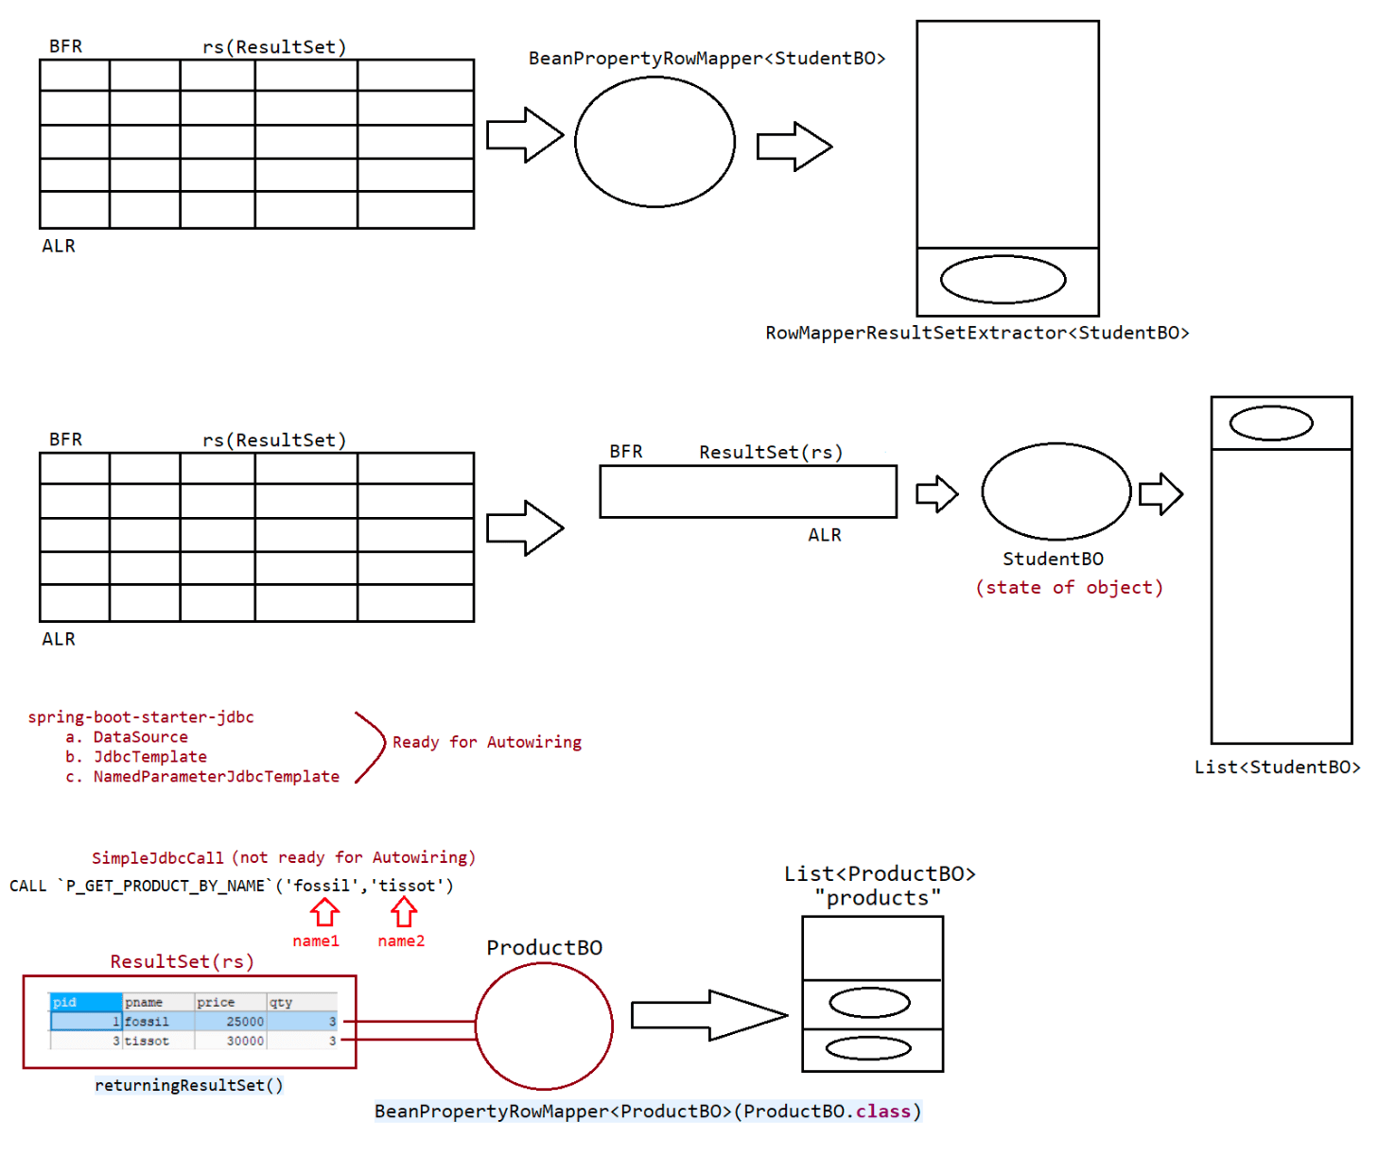

166 log4j using appender and layout

Logger Object
=============
=> enables logging on the given java class.
=> Logger logger = Logger.getLogger(current java class related to
java.lang.Class object);
eg: Logger logger = Logger.getLogger(BankAppProject.class);
=> use the following method based on the priority level to generate the log
message
logger.debug("");
logger.info("");
logger.warn("");
logger.error("");
logger.fatal("");
=> Allows to specify logger level to retrieve log messages
logger.setLevel(Level.DEBUG)[if no logger level is given then the
defualt logger level is DEBUG]
=> Both Appender object and Layout object will be added to logger object
directly or indirectly.
=> Instructions/Inputs to logger object can be hardcoded or given by using
properties file/xml file.
Appender Object
===============
=> specifies the destination where to write/record the log messages.
eg:
FileAppender,RollingFileAppender,DailyRollingFileAppender,JDBCAppender,
IMAPAppender,ConsoleAppender
=> All Appender classes implements from org.log4j.Appender(I).
Layout Object
=============
=> Given to format the log messgaes before givinig to appender for
recording/writing the destination file
eg: SimpleLayout,HtmlLayout,XmlLayout,PatterLayout......
=> All Layout classes extends from org.log4j.Layout(c)
Log4j Architecture
==================
refer diagram
To load the properties file data into java program we need to use the following
class
==
static {
===================================================================================
PropertyConfigurator.configure("src\\main\\java\\in\\ineuron\\cfgs\\
log4j.properties");
}
Using log4j to work with properties file
========================================
case1:: Working with HTMLLayout and FileAppender#For HTMLLayout and FileAppender
#specify Logger level to retrieve the log messages
log4j.rootLogger=INFO,R
#specify appender
log4j.appender.R=org.apache.log4j.FileAppender
#Specify file name
log4j.appender.R.File=D:\\log.html
#Disabling append mode on file
log4j.appender.R.append=true
#sepcify layaout
log4j.appender.R.layout=org.apache.log4j.HTMLLayout
====================================================================
Case2:: Working with Multiple Appenders
#For Working with multiple Appenders
#specify Logger level to retrieve the log messages
log4j.rootLogger=DEBUG,R,C
#related ConsoleAppender and SimpleLayout
log4j.appender.C=org.apache.log4j.ConsoleAppender
log4j.appender.C.layout=org.apache.log4j.SimpleLayout
#related to FileAppender and HTMLLayout
log4j.appender.R=org.apache.log4j.FileAppender
log4j.appender.R.File=D:/log.html
log4j.appender.R.append=true
log4j.appender.R.layout=org.apache.log4j.HTMLLayout
====================================================================
Case3:Working with FileAppender and XMLLayout
#For XmlLayout and FileAppender
##specify Logger level to retrieve the log messages
log4j.rootLogger=INFO,R
##specify appender
log4j.appender.R=org.apache.log4j.FileAppender
##Specify file name
log4j.appender.R.File=D:/info.xml
##enabling append mode on file
log4j.appender.R.append=true
##sepcify layaout
log4j.appender.R.layout=org.apache.log4j.xml.XMLLayout
===================================================================
Case4: RollingFileAppender and PatternLayout
# ForRollingFileAppender and PatternLayout
log4j.rootLogger=DEBUG,R
log4j.appender.R=org.apache.log4j.RollingFileAppender
log4j.appender.R.File=log_info.txtlog4j.appender.R.MaxFileSize=10KB
log4j.appender.R.MaxBackupIndex=3
log4j.appender.R.append=true
log4j.appender.R.layout=org.apache.log4j.PatternLayout
log4j.appender.R.layout.ConversionPattern=%d{yyyy-MM-dd HH:mm:ss} %p %10.15c %10M
%-10t %r %L %m%n
# For DailyRollingFileAppender and PatternLayout
log4j.rootLogger=DEBUG,R
log4j.appender.R=org.apache.log4j.DailyRollingFileAppender
log4j.appender.R.File=log_info1.txt
log4j.appender.R.append=true
log4j.appender.R.datePattern='.'yyyy-MM-dd-HH-mm
log4j.appender.R.layout=org.apache.log4j.PatternLayout
log4j.appender.R.layout.ConversionPattern=%d{yyyy-MM-dd HH:mm:ss} %p %10.15c %10M
%-10t %r %L %m%n
Note: In real timepractise,the popularly used appender is
"DailyRollingFileAppender" and layout is "PatternLayout".

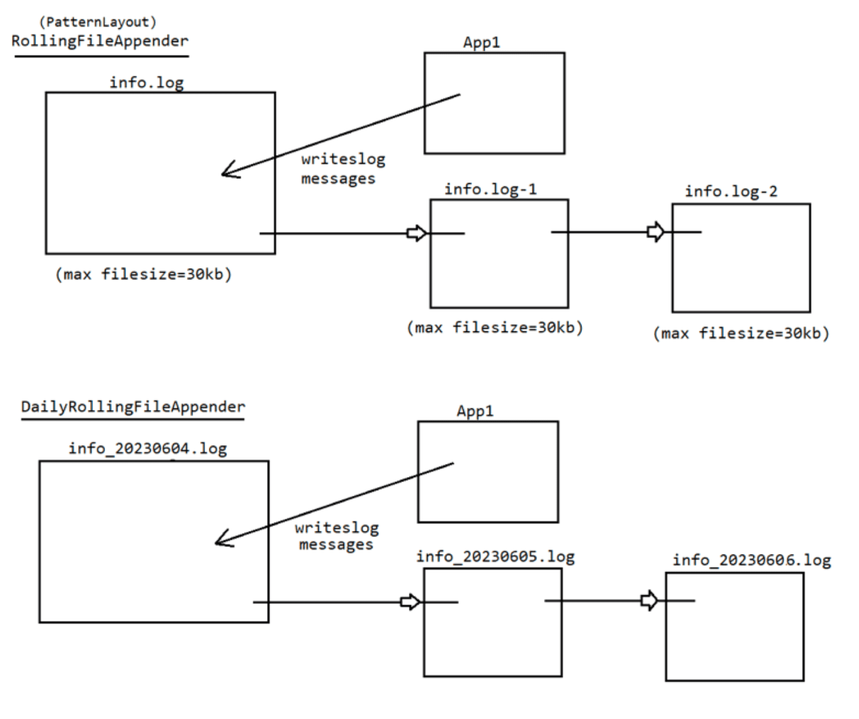

167 Spring Web MVC Lecture 1

Spring Web MVC module is developed based on 2 design patterns
a) MVC Design Pattern
b) Front Controller Design Pattern
Spring MVC Components :
1) Front Controller (Dispatcher Servlet)
2) Handler Mapper
3)Controller
4 ) ModelAndView
5 ) ViewResolver
6) View
1) Front Controller is responsible t o perform - pre processing and post processing of
incoming request o f a n a p p
(pre processing)
ex: capturing form data
taking request
4
(Post processing)
ex: sending response back to client --> client understandable format

--> Spring Web MVC based application -> DispatcherServlet as a front Controller
> DispatcherServlet -> Servlet provided by Spring MVC module
(Spring Framework Servlet)

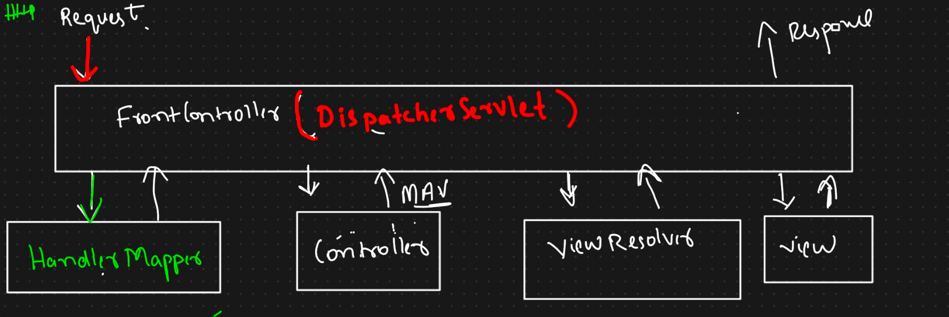

Handles Mapper - > pre defined class -- Spring Web MVC
--HM-> to identify Request Handler(Controller)
--Request Handler --> Program/app which handles incoming request
--RequestHandlers==Controllers •
--Handler Mapper -> identify request handler(Controller) and return details t o DispatcherServlet
--Controller --> responsible t o handle request
- - Spring WebMVC -- We can create our own Controllers
-- There some predefined controller classes - > MultiActionController, AbstracttCommandController etc
-- W e can create Controllers using @Controller annotation
ModelAndView --->
--> Once Request Processing is done--> Controller will return ModelAndView object to DispatcherServlet
- > ModelAndView --> predefined class avalaible in --> Spring WebMVC module
- - > ModelAndView --> Model represents Data and view represents logical view name

View Resolver - -
- > Responsible to identify view files (extension and location)
(Many internal predefined view resolvler classes - - XmlViewResolver, URLBasedViewResolver etc)
DispatcherServlet will give model date and vew file t o view component then view component is responsible
to rendering t h e data in vew files (responding back t o client in client understandable format)

Spring Web MVC -- Summary
DispatcherServlet acts as Front Controller
HandlerMapper would identify Request Handler
Conroller will process the request and return the model data and logical view name
Controller also refered as Request handler
View Resolver identifies view file (location and Extention) Prefix and Suffix
View Component will render model data on the vew file
DispatcherServlet will send response to client in client understandable format
Developing Spring Web MVC application:
springboot-starter-web dependency is used t o build web-app
@Controller annotation is s u e d t o represent our class as Spring Controller or Request Handler
@RequestMappingannotations are used t o bind Controller method t o URL pattern
Controller method returning ModelAndView Object
for ModelAndView object --a)data in form of key and value b)logical view name ( no extension).
Model data can be accessed in view file using key
@GetMapping is used to bind our data to request (HTTP GET Request)
Model is an interface -- t o store data in form of key and value pair
Model is used t o send data from Controller to View(UI)

169 Spring Web MVC 2 and Log4J setup using JDBC environment

# JdbcAppender and PatternLayout
# Define the root logger with file appender
log4j.rootLogger = ALL, DB
# Define the Jdbcappender
log4j.appender.DB=org.apache.log4j.jdbc.JDBCAppender
log4j.appender.DB.URL=jdbc:mysql:///octbatch
# Set Database Driver clas name
log4j.appender.DB.driver=com.mysql.cj.jdbc.Driver
# Set database user name and password
log4j.appender.DB.user=root
log4j.appender.DB.password=root123
# Set the SQL statement to be executed.
log4j.appender.DB.sql=INSERT INTO log_data_tab
(`thread`,`categoryname`,`dateofgeneration`,`methodname`,`lineno`,`message`,`timeel
apsed`,`prioritylevel`)
VALUES ('%t','%c',current_timestamp,'%M','%L','%m','%r','%p')
# Define the pattern layout for file appender
log4j.appender.DB.layout=org.apache.log4j.PatternLayout
SL4J
====
Simple Logging facade for java
To work with different logging tools , we need to use differnt api's.so moving from
one logging tool to another logging tool is complex.
To overcome this problem SL4j has given abstraction over multiple logging tools or
api's and provides unified api to work with any logging tool/api.
Logger levels of SL4J are
=> debug<info<trace<warn<error
note: trace can be used for "Auditing" activities.
eg: for user related activities like event handling based code execution will be
logged with the support of "trace" log messages.
eg: button clicked=> actionPerformed() method executed-> this can be logged
through "trace" level.
dependencies required are
=========================
<dependency>
<groupId>org.slf4j</groupId>
<artifactId>slf4j-api</artifactId>
<version>2.0.7</version>
</dependency>
<!-- https://mvnrepository.com/artifact/org.slf4j/slf4j-simple -->
<dependency>
<groupId>org.slf4j</groupId>
<artifactId>slf4j-simple</artifactId>
<version>2.0.7</version>
<scope>test</scope>
</dependency><dependency>
<groupId>org.slf4j</groupId>
<artifactId>slf4j-log4j12</artifactId>
<version>2.0.7</version>
</dependency>
Note: SL4j generates the log messages by using log4j setup internally based on the
instructions collected from log4j.properties
Springboot internally uses SL4j with log4j to generate the messages ,we can
control these messages through "application.properties" file.

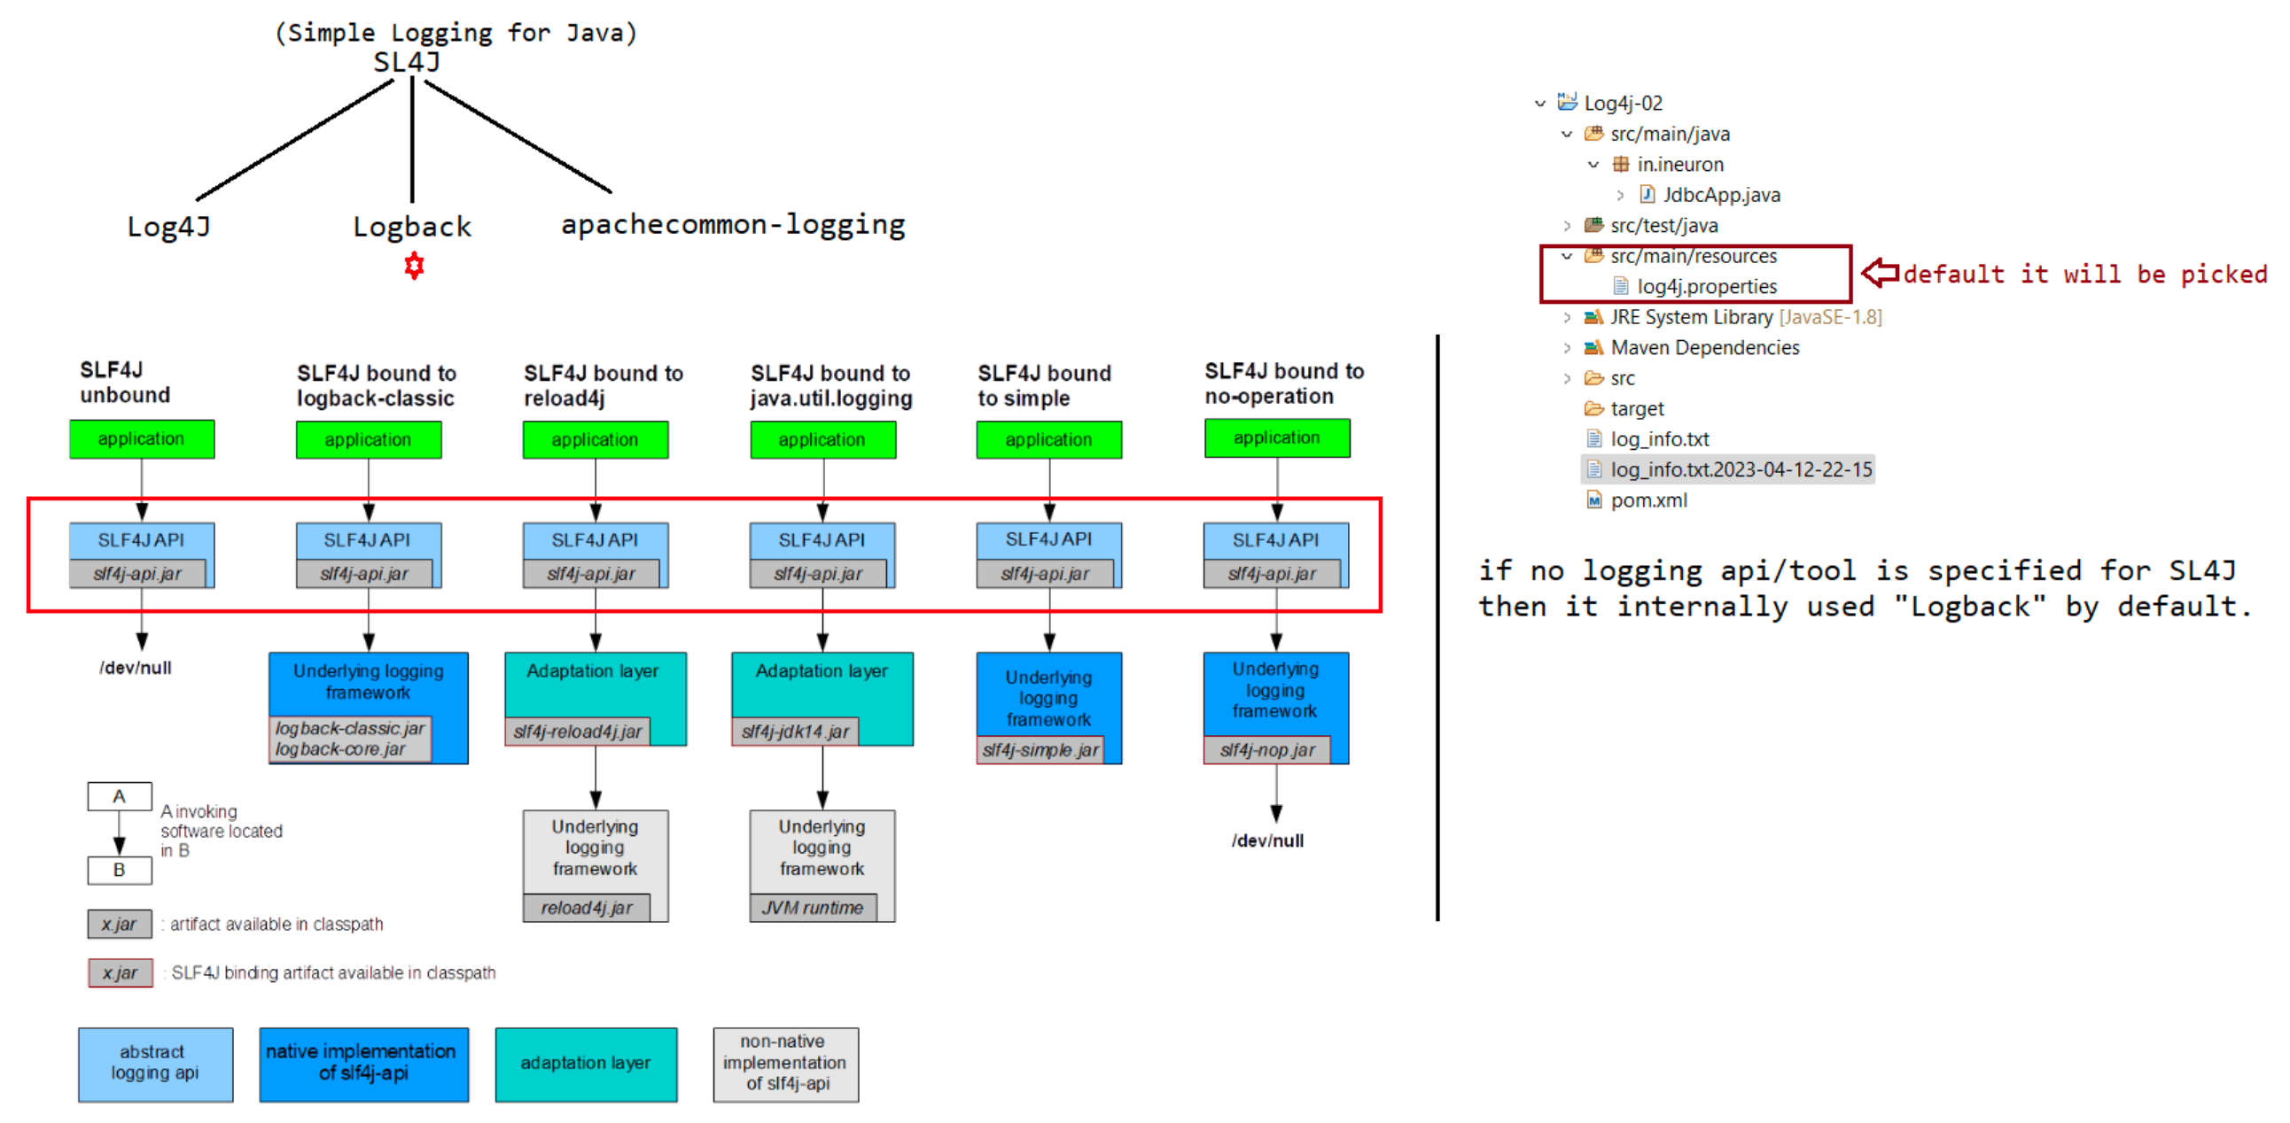
Todays Request Mappings & Context Path
-> @RequestMapping - method will be binded to GET request (default)
Spring 4.0 onwards
To bind our method to GET request @GetMapping
-POST request@PostMapping
Spring
- - @PutMapping
- @DeleteMapping
We can create Multiple Controllers in Spring Web MVC
One Controller can have multiple methods binding to request
Every Controller of project can map class level url pattern
Methods must have unique url pattern
Spring Boot application are running in Embedded Container so we may not require to specify project name in url (default behaviour)
If we want to include priect name in the url to access the controller methods, we can add Context-Path in project(application properties file)
Embedded containers will run on 8080 port number by default. To change the port number we use server.port =9090. in application properties file
Adding Context path for Spring Boot Application
server.servlet.context-path= /AppName
Note: By Default context-path for Boot application is empty

170 Spring ORM intergration using XML and performing layer approach CRUD operation of HibernateTemplate class

What is ORM?
It stands for Object Relational Mapping.
The process of linking DB tables with java classes(BO) and DB table column names
with properties of classes and
having synchronization b/w them is called "OR-Mapping".
Synchronization
The modification done in the Object of java classes will reflect to DB table
records and vice versa.
ORM tools ===> hibernate,ibatis,eclipselink,.....
SpringORM
=========
=> It is not another ORM-Framework
=> It is a SpringModule which provides abstraction on multiple orm frameworks like
hibernate,ibatis etc
=> It is available to simplify objects based on O-R mapping persistence logic.
=> It provides multiple template classes like "HibernateTemplate" which is given
to avoid boiler plate code
of O-R mapping persistence logic.
Plain hibernate
===============
1. Create a Configuration Object(To activate hibernate s/w)
2. Create a Session Factory Object
3. Create a Session Object
4. Begin Transaction
5. Perform persistence operation [ApplicationLogic]
6. use commit/rollback operation
7. close session/sessionfactory objects
In the above steps 1,2,3,4,6 and 7 is a common operation which is referred as
"Boiler plate code".
Using SpringORM all the "Boiler plate code" steps will be taken care by a Template
class called "HibernateTemplate".
Spring ORM Code(Integration with hibernate)
===========================================
1. Create an Inject Hibernate Template class object
2. Perform Persistence operation
Note: boiler plate problem is avoided.
Advantages of Spring ORM
========================
1. Avoids boiler plate code by suppling Template classes
2. Common Exception handling(we need to just handler ORM specification excpetion==>
DataAccessException)
3. Persistence logic is portable across multiple DB S/w and Entity classes are also
portable across multiple ORM Frameworks.
4. Common Transaction Management Support
5. Common Single Row Operation(given by JPA) and Common JPQL(Java Persistence Query
Language)
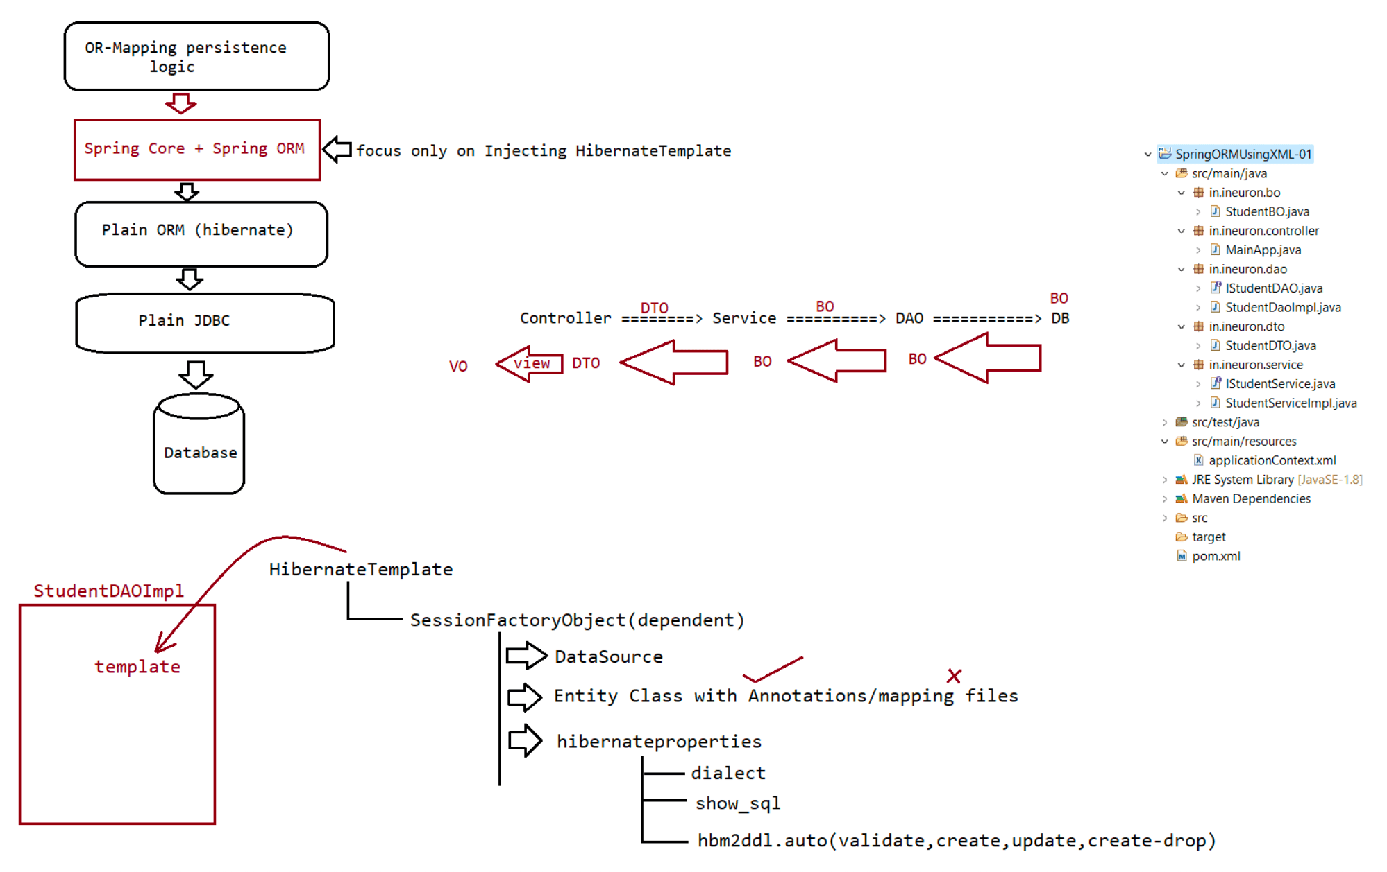

171 Spring Web MVC part 3

context-path in spring boot app is empty by default
To configure context-path for spring boot application
server.servlet.context-path=/app
We must specify context-path in URL to access resources(controller methods)
Todays: discussion: Sending Data from Controller t o Ul and Ul t o controller
Sending Data from Controller t o Ul
Whenever client send a request, Controller methods are responsible to process that request and response back to client
--> Controller can response t o client in 2 ways:
a) With View (Using Presentation File)
b) Raw response
Model object is used t o send response back to client in view file
In Model Object data is stored in key-value format
The data again is accessed in view file using key

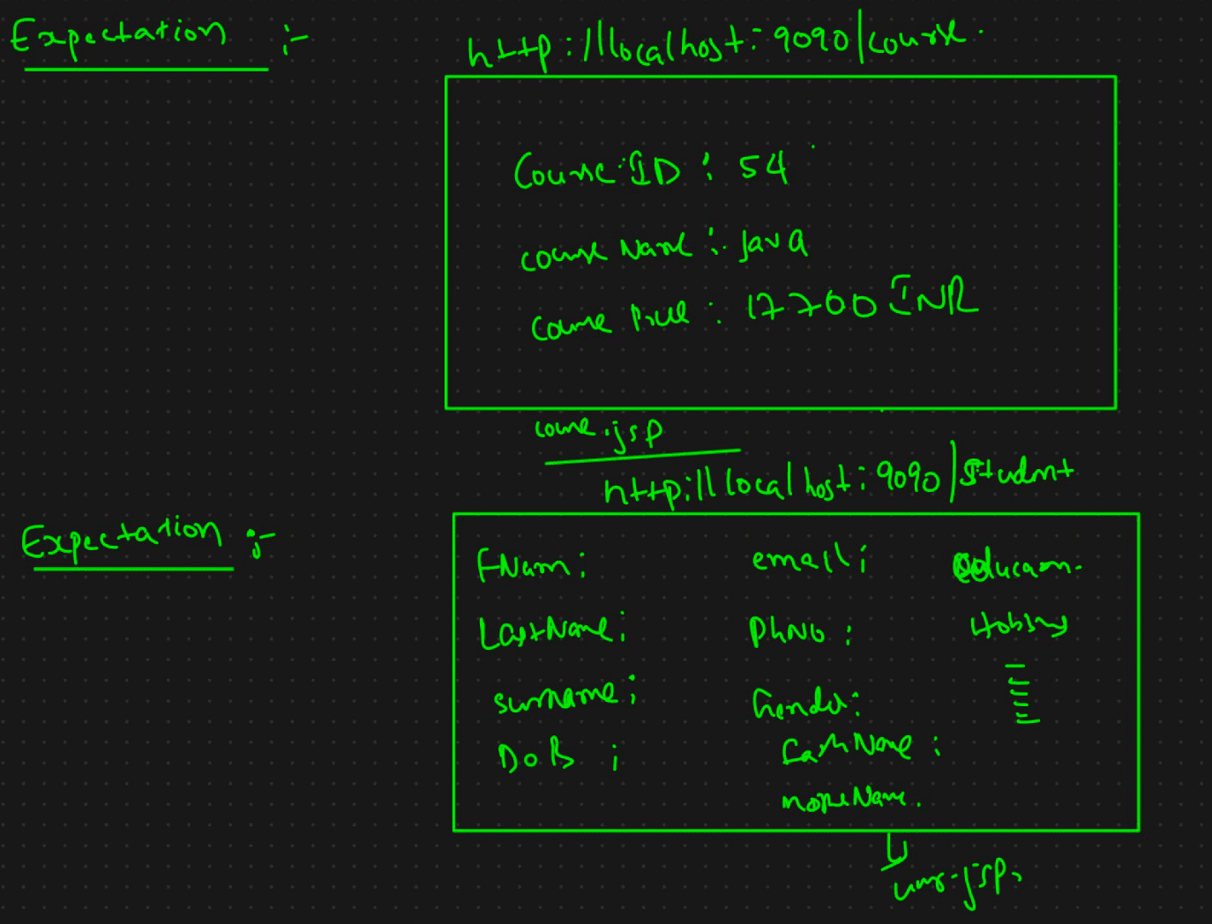

To send data from controller to Ul pages we use Model Object
Model is an interface in Spring MVC
Using Model data is stored in the form of key-value pair
The data which is there with model object can b e accessed in view file using key
Q) Can we access Object data in view file?
yes w e c a n
Q) can we store one object a s a value in Model?
y e s w e c a n
Sending Data from Ul to Controller:
W e c a n d o
a) Query Parameter
b ) Path Parameter
c) Forms
Query param:
Request URL: http://localhost:9090/service?name=Najafi
Response: Najafi, Welcome to iNeuron .ai
Request URL: http://localhost:9090/service?name=Hyder
Response: Hyder, Welcome to iNeuron .ai
Query Parameter:
- > Query parameters used to send the data t o server in URL
- > In URL, Query parameters must be there at the end
- > Query parameters starts with ?
- > Query parameters represents data in the form of key-value pair
example: ?name=Najafi
- > What if there is more than one query parameter in URL?
yes, we can send data o r more than one query parameter using & separator
example: ?id= 1&name=Najafi
--> To receive Query parameters value we always use @RequestParam annotation in Controller
P a t h Params:
- - > Path params a r e used t o s e n d d a t a t - > Path param contains values(no key)
- - > Path param can b e given at any position in URL
o server using URLin URL)
example: http://localhost:9090/booksinfo/{name}/author/{authorname}
> To read path params we will use @PathVariable("segment-name") in Controller

